Abstract

In this lab I have designed a barrel shifter for the ARMv4 ALU. A barrel shifter takes in a 32-bit number and transforms it into an 8-bit number and a 3-bit rotate.

* Purpose: The barrel shifter is needed because the ARMv4 instruction can only hold 11-bits for the input, but the ALU can handle 32-bits. To work around this ARM has allocated 8-bits for the immediate and 3-bits for the rotate.
* How it works: The barrel shifter takes in a 32-bit number and shifts it x amount of times until all the bits from the most significant high bit to the least significant high bit can fit in 8-bits. x/2 is the rotate value.
* Test: As count increases, the value of OUT_SRC2 gets divided by 4.

Conclusion

This lab was straightforward in implementing the barrel shifter. The only issue I had was in the with select, I flipped the first IN_SRC2 with the second IN_SRC2.

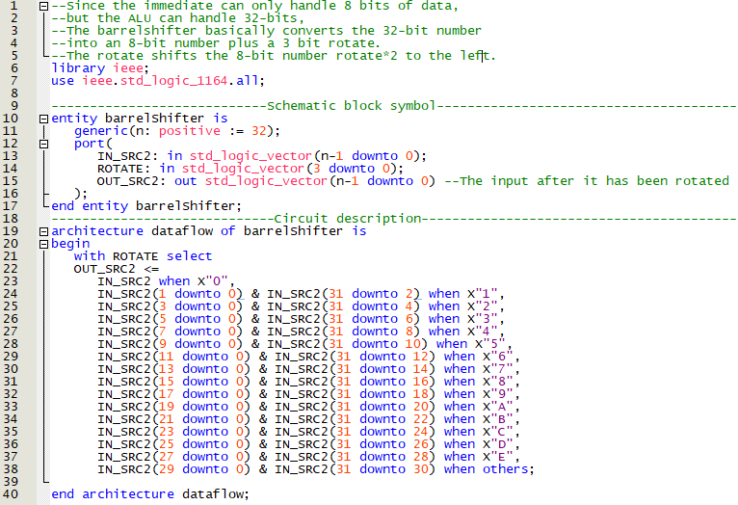

Figure 1: VHDL Code

Figure 2: Count Test